Design Log

Cumberland Valley HS C6

Detector Building

Srihari Rajesh and Viraj Singh

**Device Construction and Calibration: 4.b.i**

The device was constructed with an Arduino Uno, 1 mini breadboard, and 1 through-hole breadboard, and a NAU7802 IC. It consists of one red LED, one green LED, one blue LED, three 330 Ohm resistors(for the leds), two 47 Ohm resistors, several capacitors and a student-constructed load cell made from 4 strain gauges with plexiglass platforms on the top and bottom. We made the load cell by using a cnc machine to drill two overlapping holes on the side of an aluminum bar. This was to make it easier for the bar to bend when it experiences weight force caused by the masses. Then, we glued two strain gauges on the top and the bottom using cyanoacrylate. After that, we connected the strain gauges to the solder pad and then we soldered wires to the solder pad. Two circuits comprise our device, one of which is for the LEDs, and the other circuit is for the NAU7802 ADC. The three 330 Ohm resistors in the LED circuit are connected in series to each color LED: red, green, and blue. The strain gauges on the load are connected in a wheatstone bridge formation to determine the small changes in voltage caused by the weight force. This voltage across the bridge is then sent into the NAU7802 IC to be amplified so it can be read and printed by the Arduino Uno. To be able to read this using the Arduino Uno we used an Adafruit library to read one bit at a time during the specified clock speed. This is only used for functionality not for calibration. Calibration is done by recording the voltage values of known masses and creating a line of best fit. On top of the load cell there is a circular piece of plexiglass so that we can place all masses with at most an 8 cm diameter. The positive terminals of the red, green, and blue LEDs are: 5,4,2, respectively. We calibrated our device using several 50g masses and getting different voltages to create a relationship between voltage and mass.

**Labeled Images: 4.b.i**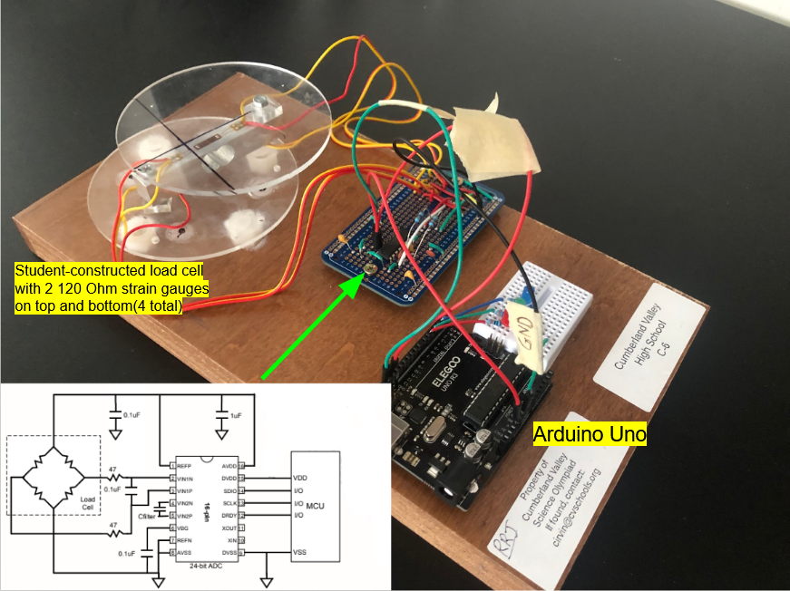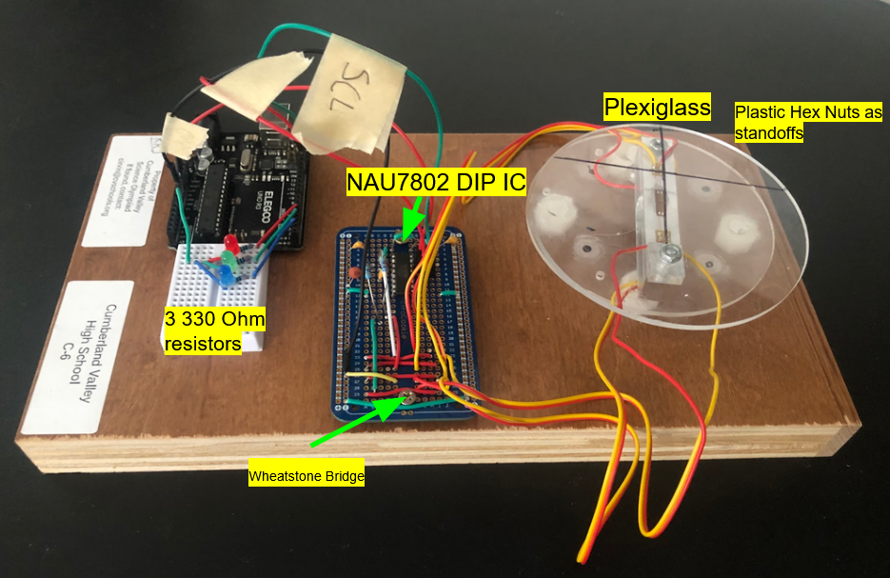

**Data Table: 4.b.ii**

We used two different relationships for calculating mass values for different ranges. The voltage is compared through a threshold and that determines the equation used by the program.

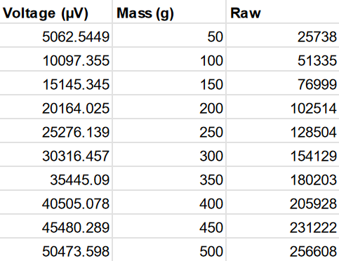

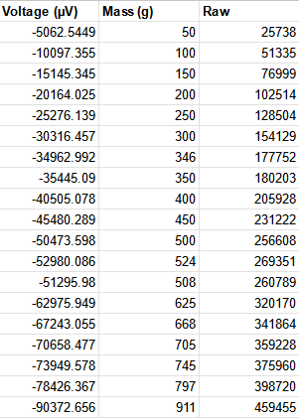

**Graphs and Equation: 4.b.iii,4.b.iv**

Just datapoints graph

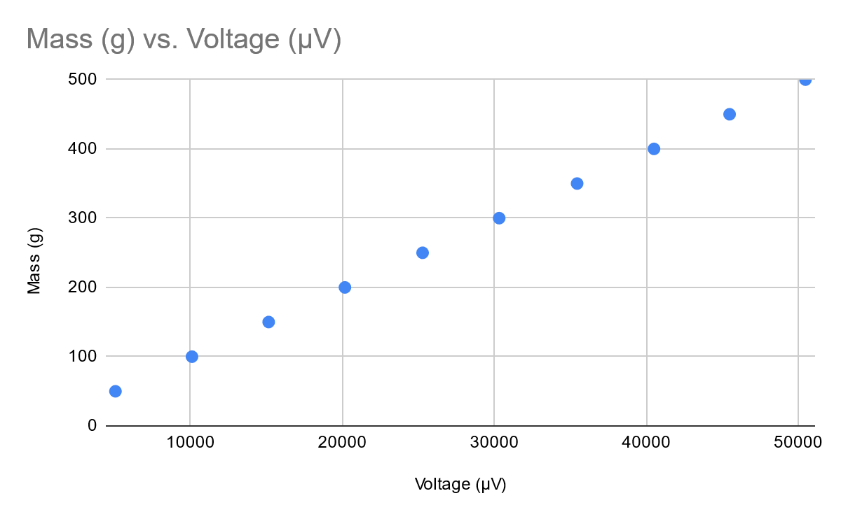

Datapoints with function overlaid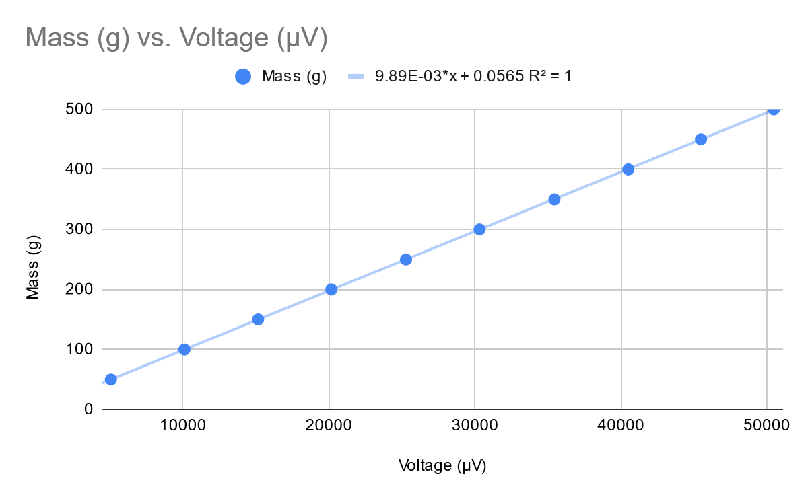

**Equation:**

**Graphs and Equation: 4.b.iii,4.b.iv**

Just datapoints graph

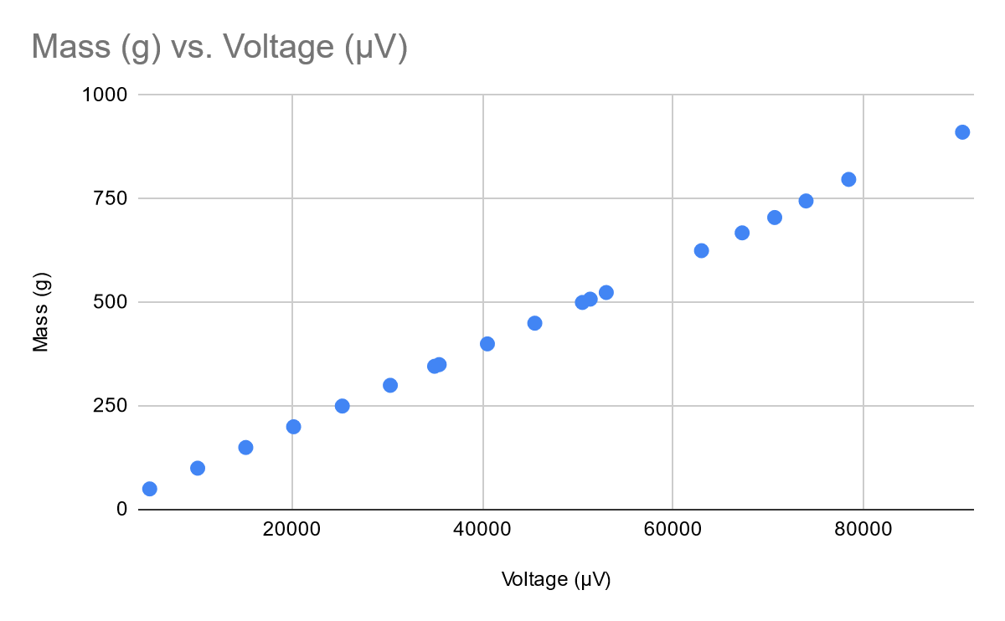

Datapoints with function overlaid

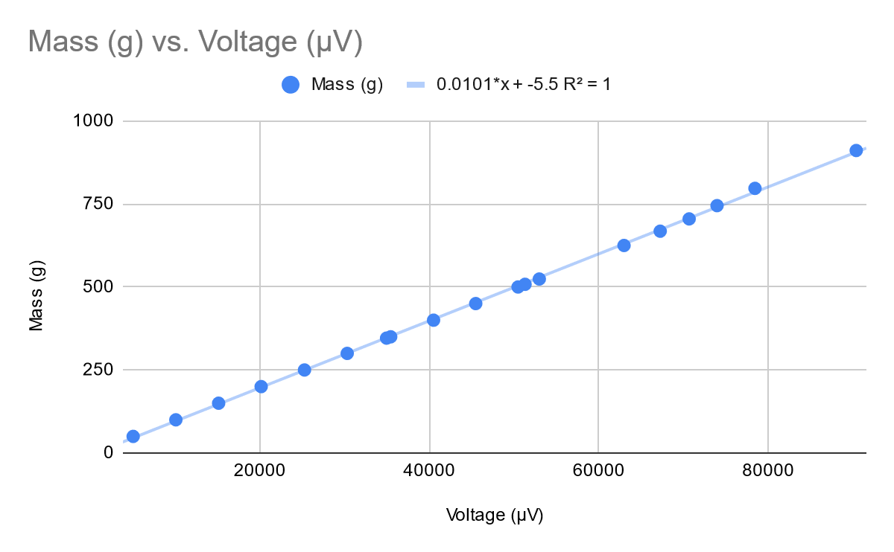

**Equation:**

**CNC Machined Part**

* In order to create our load cell, I designed a load cell in Onshape to get machined - below is the link to the part I created
* <https://cad.onshape.com/documents/7fce2e6086913cbe35afaaf9/w/af9e087dfbc71a0ca221b9a1/e/8575285e19131f235fc6b9c5?renderMode=0&uiState=642bf30b2784d231f4f0d97b>
* Above is a isometric view, top view, and front view of the part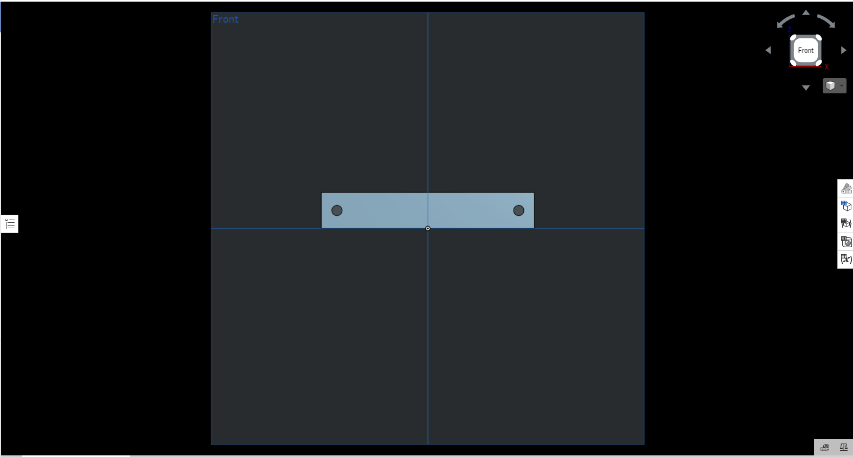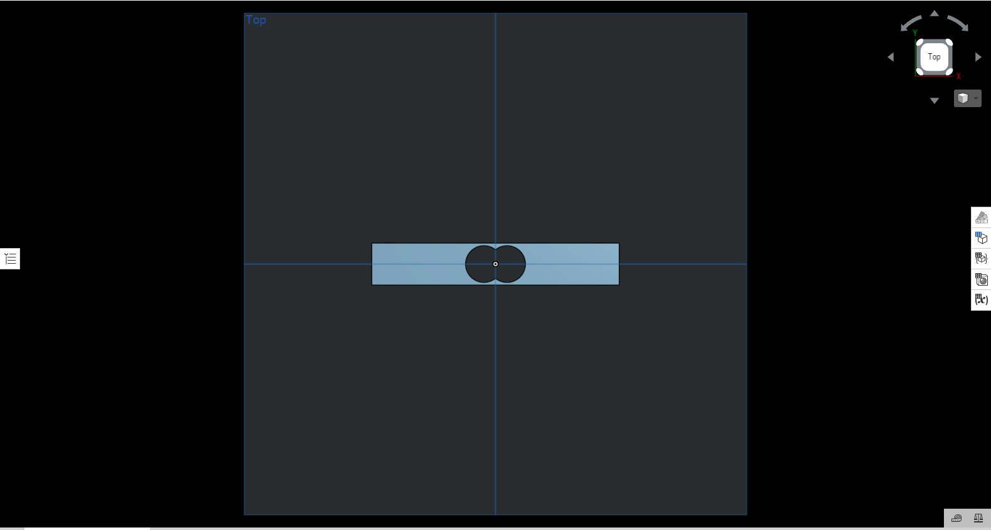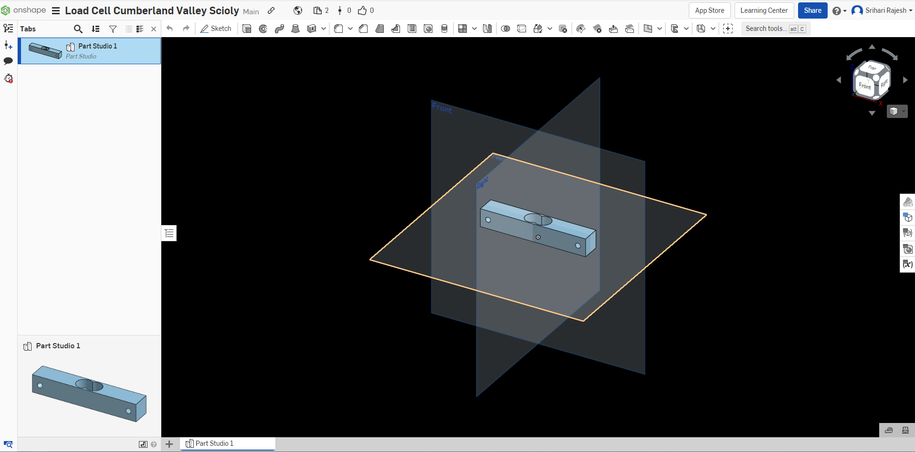
* We sent the created .STEP file to a local machine shop and they were able to use a CNC milling machine to create the part for us
* The part was created out of aluminum
* Using this part, we were able to attach our strain gauges to it and connect it to our voltage divider circuit to create a working load cell

**Program Code**

RED - vi

YELLOW - vii

// Viraj Singh and Srihari Rajesh

// #C-6

// Cumberland Valley High School

#include <Adafruit_NAU7802.h>

Adafruit_NAU7802 nau;

const int redPin = 5;

const int greenPin = 4;

const int bluePin = 2;

void setup() {

Serial.begin(115200);

pinMode(redPin, OUTPUT);

pinMode(greenPin, OUTPUT);

pinMode(bluePin, OUTPUT);

nau.begin();

nau.setLDO(NAU7802_3V0);

nau.setGain(NAU7802_GAIN_128);

nau.setRate(NAU7802_RATE_10SPS);

for (uint8_t i=0; i<10; i++) {

while (! nau.available()) delay(1);

nau.read();

}

while (! nau.calibrate(NAU7802_CALMOD_INTERNAL)) {

delay(1000);

}

while (! nau.calibrate(NAU7802_CALMOD_OFFSET)) {

delay(1000);

}

}

bool stopped = false;

int32_t offset = 0;

char c;

void loop() {

if(!stopped)

{

while (!nau.available())

delay(1);

int32_t val = nau.read();

if (Serial.available() > 0) {

c = Serial.read();

if(c == 's')

stopped = true;

else

offset = val;

}

int32_t num = val-offset;

float voltage = num * ((3.3*pow(10,6))/16777215);

float mass =(voltage<=55000)?(0.00989*(voltage)-0.0565):

(0.0101*(voltage)- 5.5);

Serial.print("Voltage "); Serial.println(String(voltage,4));

Serial.print(" Raw "); Serial.println(num);

Serial.print(" Mass "); Serial.println(String(mass,1));

showLED(mass);

delay(100);

}

else

{

if (Serial.available() > 0) { // is a character available?

c = Serial.read();

if(c == 's')

stopped = false;

}

}

}

const float redMin = 0;

const float redMax = 200;

const float greenMin = 127;

const float greenMax = 250;

const float blueMin = 591;

const float blueMax = 1000;

void showLED(float m) {

digitalWrite(redPin, LOW);

digitalWrite(greenPin, LOW);

digitalWrite(bluePin, LOW);

if (m >= redMin && m <= redMax) {

digitalWrite(redPin, HIGH);

}

if (m >= greenMin && m <= greenMax) {

digitalWrite(greenPin, HIGH);

}

if (m >= blueMin && m <= blueMax) {

digitalWrite(bluePin, HIGH);

}

}